
2025 - 2026 Spring
Software Engineering Graduation Design II
TITLE OF YOUR PROJECT

Project Short Title | scx-adapt
Project Full Title | scx-adapt — Adaptive scheduling policies for Linux operating system
Subject Classification | Operating Systems Programming with Machine Learning
Student name(s)  (Team members of project) | Doğukan Meral  Hamza Onur Karagür

Abstract
Modern operating systems rely heavily on CPU schedulers to efficiently distribute processing resources among running tasks. Traditional Linux schedulers are generally designed with static scheduling policies that may not adapt effectively to changing workload conditions. This limitation can reduce overall system efficiency, especially in environments with dynamic or mixed workloads. The purpose of this project is to develop an adaptive Linux scheduler management package named scx-adapt, based on the Linux Scheduler Class eXtension (SCX) framework. The system enables users to dynamically switch between multiple schedulers and optionally activate a Machine Learning-based scheduler capable of adapting scheduling decisions according to runtime system behavior.
Modern operating systems rely heavily on CPU schedulers to efficiently distribute processing resources among running tasks. Traditional Linux schedulers are generally designed with static scheduling policies that may not adapt effectively to changing workload conditions. This limitation can reduce overall system efficiency, especially in environments with dynamic or mixed workloads. The purpose of this project is to develop an adaptive Linux scheduler management package named scx-adapt, based on the Linux Scheduler Class eXtension (SCX) framework. The system enables users to dynamically switch between multiple schedulers and optionally activate a Machine Learning-based scheduler capable of adapting scheduling decisions according to runtime system behavior.
The originality of this work lies in combining adaptive scheduling, runtime scheduler management, and lightweight Machine Learning techniques within a modular Linux scheduling framework. The project aims to improve flexibility, reliability, and performance while maintaining low system overhead. This study may benefit researchers, system administrators, and advanced Linux users by providing a safer and more adaptable scheduling environment for modern computing systems.

Keywords: Linux Scheduler, SCX, eBPF, Machine Learning, Operating Systems, CPU Scheduling, Adaptive Systems

Acknowledgements (if any)
I would like to express my sincere gratitude to my project supervisor, Dr. Aytun Onay, for his invaluable guidance, encouragement, and continuous support throughout the course of this project. His expertise, insightful feedback, and constructive suggestions were instrumental in shaping both the direction and the quality of this work. I amalso thankful to the other academicians at the university who contributed through discussions, lectures, and academic resources that helped strengthen my understanding of operating systems, kernel development, and performance optimization. Their dedication to teaching and research provided a strong academic foundation for this project. Special appreciation is extended to the broader research and developer community working in the area of Linux scheduling and kernel development. The contributions of researchers, maintainers, and open-source developers—through documentation, publications, mailing lists, and code repositories—were essential in enabling practical experimentation and informed design decisions. Their ongoing efforts to advance the Linux scheduler ecosystem served as both a technical reference and a source of inspiration. Finally, I would like to thank all individuals, colleagues, and peers who offered support, feedback, and motivation during the development of this project. Their assistance and encouragement were greatly appreciated.
Table of Contents
Abstract
Keywords: Write at least 5 keywords (separated by commas) describing your work
Ch1: Introduction
1.1 Problem Statement
1.2 Scope
Ch2: Project Plan
2.1 Methodology
2.2. Time Schedule (Gantt Chart)
2.3. Deliverables List
Ch3: Literature Review
Ch4: Requirements
4.1 Overall Description of the Project
4.1.1 Product Perspective
4.1.2 Product Functions
4.1.3 User Characteristics
4.1.4 Constraints
4.1.5 Assumptions and Dependencies
4.2 Specific Requirements
4.2.1 External Interface Requirements
4.2.2 Functional requirements
4.2.3 Quality Requirement (HW, OS, Database, programming environment, performance, security, reliability, etc)
Ch5: Design
5.1 Software Architecture
5.1.1 Actors
5.1.2 Constraints
5.1.3 Software Architecture
5.2 Views
5.2.1 Logical View
5.2.2 Process View
5.2.3 Deployment View
Ch6: Implementation & Test
6.1 Implementation
6.2 Test
Ch7: Evaluation
Ch8: Impact of the Project & Compliance with the Constraints
8.1 Compliance with the Realistic Constraints
8.2 Impact of the Project
Ch9: Conclusions
Appendix A
References

Acronyms

AI | Artificial Intelligence
CLI | Command Line Interface
CPU | Central Processing Unit
eBPF | Extended Berkeley Packet Filter
I/O | Input / Output
ML | Machine Learning
OS | Operating Systems
SCX | Scheduler Class eXtension
SRS | Software Requirements Specification

Ch1: Introduction

1.1 Problem Statement
Modern Linux systems rely on CPU schedulers to distribute processing resources among running applications and system processes. Traditional schedulers are generally designed using fixed scheduling policies optimized for common workloads. However, modern computing environments frequently experience rapidly changing workloads involving gaming, virtualization, compilation, artificial intelligence tasks, server operations, and real-time applications. Static schedulers may fail to adapt efficiently to these varying workload conditions, leading to reduced performance, inefficient CPU utilization, and inconsistent responsiveness.
In addition, current scheduler management methods are limited in flexibility and runtime adaptability. Switching between schedulers often requires manual intervention, system reconfiguration, or kernel recompilation. Existing systems also provide limited fault tolerance when custom schedulers fail or become unstable.
This project aims to solve these problems by developing an adaptive scheduler management package named scx-adapt using the Linux SCX framework. The proposed system allows runtime scheduler switching, workload monitoring, Machine Learning-based adaptive scheduling, and automatic scheduler recovery mechanisms. The project is important because efficient CPU scheduling directly affects system performance, energy efficiency, responsiveness, and user experience in modern computing systems.

1.2 Scope
The scope of this project includes the development of a Linux scheduler management package operating on Linux systems that support SCX and eBPF technologies. The system will provide:
- Runtime scheduler loading and switching.
- Machine Learning-based adaptive scheduling.
- Scheduler monitoring and performance analysis.
- Scheduler fault detection and recovery.
- Command-line management tools.
- Logging and reporting mechanisms.
The project mainly targets advanced Linux users, system administrators, and operating systems researchers. The initial implementation will focus on Linux x86_64 systems. GUI support and advanced distributed scheduling features are considered future improvements and are outside the current project scope.

Ch2: Project Plan

2.1 Methodology
This project will follow an Agile-based development methodology combined with iterative prototyping. Since the project involves research-oriented development and experimentation with Linux scheduling systems, an iterative approach is more suitable than traditional linear methodologies.
The development process will include the following phases:
- Literature Review and Research
- Requirement Analysis
- Architecture and Design
- Scheduler Development
- Machine Learning Integration
- Monitoring and Fault Recovery Development
- Testing and Performance Evaluation
- Documentation and Final Reporting
Short development cycles will be used to continuously test scheduler behavior and system stability during implementation.

2.2. Time Schedule (Gantt Chart)

WP /  Task No | WP /  Task Name | Start Date | End Date | Weeks
 |  |  |  | 1 | 2 | 3 | 4 | 5 | 6 | 7 | 8 | 9 | 10 | 11 | 12 | 13 | 14 | 15 | 16 | 17 | 18
WP1 | Literature Review | 01/12/2025 | 20/12/2025
WP2 | Requirement Analysis | 21/12/2025 | 15/01/2026
WP3 | Architecture Design | 16/01/2026 | 31/01/2026
WP4 | SCX Scheduler Development | 01/02/2026 | 01/03/2026
WP5 | CLI & Monitoring System Development | 02/03/2026 | 25/03/2026
WP6 | ML Integration | 01/05/2026 | 20/05/2026
WP7 | Fault Recovery & Scheduler Safety System | 21/04/2026 | 05/05/2026
WP8 | Testing, Optimization & Debugging | 06/05/2026 | 25/05/2026
WP9 | Final Documentation | 26/05/2026 | 03/06/2026
WP10 | Final Presentation Preparation | 04/06/2026 | 05/06/2026

2.3. Deliverables List

ID | Type | Description | Due Date
D1 | Document | Software Requirements Specification | 11/04/2026
D2 | Document | Architecture Design Report | 05/05/2026
D3 | Software | Scheduler Management CLI | 15/05/2026
D4 | Software | ML-Based Scheduler Module | 01/06/2026
D5 | Software | Monitoring and Recovery System | 10/06/2026
D6 | Document | Final Project Report | 30/06/2026

Ch3: Literature Review
- Lozi, J-P., Lepers, B., Funston, J., Gaud, F., Quéma, V. and Fedorova, A. (2016) The Linux scheduler: a decade of wasted cores. In: Proceedings of the 11th European Conference on Computer Systems (EuroSys 2016). New York: ACM, pp. 1–16.

- Li, L. (2024) ‘Advances in CPU scheduling algorithms in operating systems’, Highlights in Science, Engineering and Technology, 120, pp. 8–13.

- H T, M., H M,M., Pradeep, N.R. and M, V. (2024) ‘CPU scheduling algorithms performance analysis in the RISC-V xv6 operating system environment’, Journal of Integrated Science and Technology, 13(3), pp. 1–8.

- Khushboo (2025) ‘A comparative study of CPU scheduling algorithms for efficient process management’, International Journal for Research in Applied Science and Engineering Technology (IJRASET), 13(1), pp. 1–7.

- Goel, N. and Garg, R.B. (2013) ‘A comparative study of CPU scheduling algorithms’, arXiv preprint, arXiv:1307.4165.

- Pan, W. (2024) ‘Comparison and analysis of scheduling algorithms: exploring performance, time, fairness, and applicable scenarios’, Highlights in Science, Engineering and Technology, 120, pp. 14–21.

- Acharjya, P.P., Koley, S., Barman, S. and Mukherjee, R. (2022) ‘A study of CPU scheduling techniques in comparison’, Turkish Journal of Computer and Mathematics Education, 11(2), pp. 896–905.

- González-Rodríguez, M. (2024) ‘Study and evaluation of CPU scheduling algorithms’, Journal of Computer Science, 19(4), pp. 1–15.

- Wang, X., Jia, S., Huang, Z., Cao, J. and Song, M. (2025) ‘Mixture-of-Schedulers: an adaptive scheduling agent as a learned router for expert policies’, arXiv preprint, arXiv:2511.11628.

- Kahu, S.Y. (2025) ‘KernelOracle: predicting the Linux scheduler’s next move with deep learning’, arXiv preprint, arXiv:2505.15213.

- Chen, J., Banerjee, S.S., Kalbarczyk, Z.T. and Iyer, R.K. (2020) ‘Machine learning for load balancing in the Linux kernel’, in: Proceedings of the 11th ACM SIGOPS Asia-Pacific Workshop on Systems (APSys 2020). New York: ACM, pp. 1–8.

- Han, J. and Lee, S. (2020) ‘Performance improvement of Linux CPU scheduler using policy-gradient reinforcement learning for Android smartphones’, IEEE Access, 8, pp. 212266–212276.

- Negi, A. (2017) ‘Applying machine learning techniques to improve Linux scheduling’, in: Proceedings of the IEEE TENCON Conference. Piscataway, NJ: IEEE, pp. 1–6.

- Sarwar, N. (2016) ‘Designing a model for improving CPU scheduling by using machine learning’, International Journal of Computer Science and Information Security, 14(8), pp. 1–6.

- Anusha, G.H., et al. (2023) ‘ML engine for Linux scheduler’, Journal of Software Engineering and Simulation, 9(7), pp. 20–29.

Ch4: Requirements

4.1 Overall Description of the Project

4.1.1 Product Perspective
The proposed system operates as a modular Linux scheduling management package that interacts with the Linux kernel through SCX and eBPF interfaces. The system extends the existing Linux scheduling infrastructure instead of replacing the Linux kernel scheduler architecture.

4.1.2 Product Functions
The system will provide the following major functions:
- Dynamic scheduler switching.
- Scheduler loading and unloading.
- Runtime workload monitoring.
- Machine Learning-based adaptive scheduling.
- Scheduler fault detection and automatic recovery.
- Scheduler logging and reporting.
- CLI-based management tools.

4.1.3 User Characteristics
The intended users include:
- Advanced Linux users.
- System administrators.
- Operating systems researchers.
- Developers working with kernel technologies.
Users are expected to have basic knowledge of Linux systems and command-line environments.

4.1.4 Constraints
- Linux kernel must support SCX and eBPF.
- Root privileges are required.
- Real-time scheduling overhead must remain minimal.
- ML inference latency must not significantly reduce system performance.

4.1.5 Assumptions and Dependencies
- SCX support is available on the target Linux kernel.
- Alternative schedulers are available for fallback operations.
- Users have administrative privileges.
- System and monitoring APIs are accessible.

4.2 Specific Requirements

4.2.1 External Interface Requirements
Command Line Interface:
The system shall provide a command-line interface for:
- Starting and stopping schedulers.
- Enabling/disabling ML scheduling.
- Viewing system metrics.
- Viewing logs.
- Configuring scheduler parameters.
Logging Interface:
The system shall support logging through syslog or equivalent Linux logging services.

4.2.2 Functional requirements
- The system shall dynamically switch between schedulers at runtime.
- The system shall collect runtime workload metrics.
- The system shall provide Machine Learning-based scheduling decisions.
- The system shall log scheduling events and performance data.
- The system shall detect scheduler failures.
- The system shall attempt automatic scheduler recovery.
- The system shall disable unstable schedulers after repeated failures.
- The system shall automatically switch to safe schedulers during failures.
- The system shall provide users with scheduler performance information.

4.2.3 Quality Requirement (HW, OS, Database, programming environment, performance, security, reliability, etc)

Hardware Requirements

Multi-core CPU.

Minimum 8 GB RAM recommended.

Operating System Requirements

Linux distribution with SCX support.

x86_64 architecture.

Programming Environment

C/C++ for low-level scheduling components.

Python or Go for monitoring and CLI tools.

Performance Requirements

Scheduler switching latency below 100 ms.

Monitoring overhead below 5% CPU usage.

Security Requirements

Only privileged users may modify schedulers.

Secure interaction with kernel space.

Reliability Requirements

Automatic fallback mechanisms must exist.

System stability must be maintained during scheduler failures.

Ch5: Design

5.1 Software Architecture

5.1.1 Actors
- System Administrator
- Advanced Linux User
- Researcher
- Linux Kernel
- Machine Learning Module

5.1.2 Constraints
- Kernel compatibility constraints.
- Low latency requirements.
- Secure kernel interaction.
- Limited runtime overhead.

5.1.3 Software Architecture
The architecture consists of the following components:
- Scheduler Manager
- SCX/eBPF Interface Layer
- Machine Learning Module
- Monitoring System
- Recovery and Fault Management System
- CLI Interface
- Logging System

5.2 Views

5.2.1 Logical View
This section will include the following logical views:
- Class diagram (must)
- ER Diagram (if needed)
- Package Diagram (if needed)

5.2.2 Process View

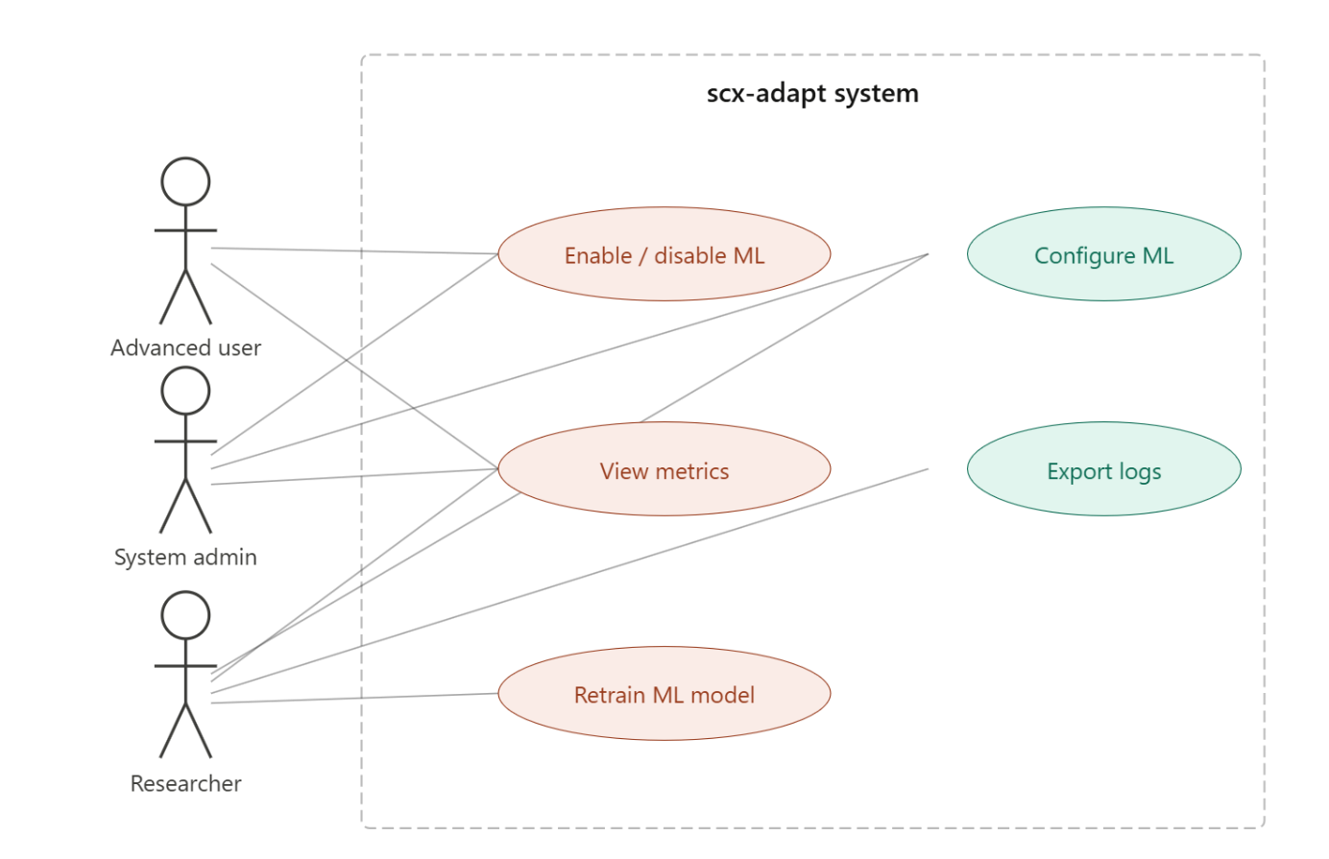

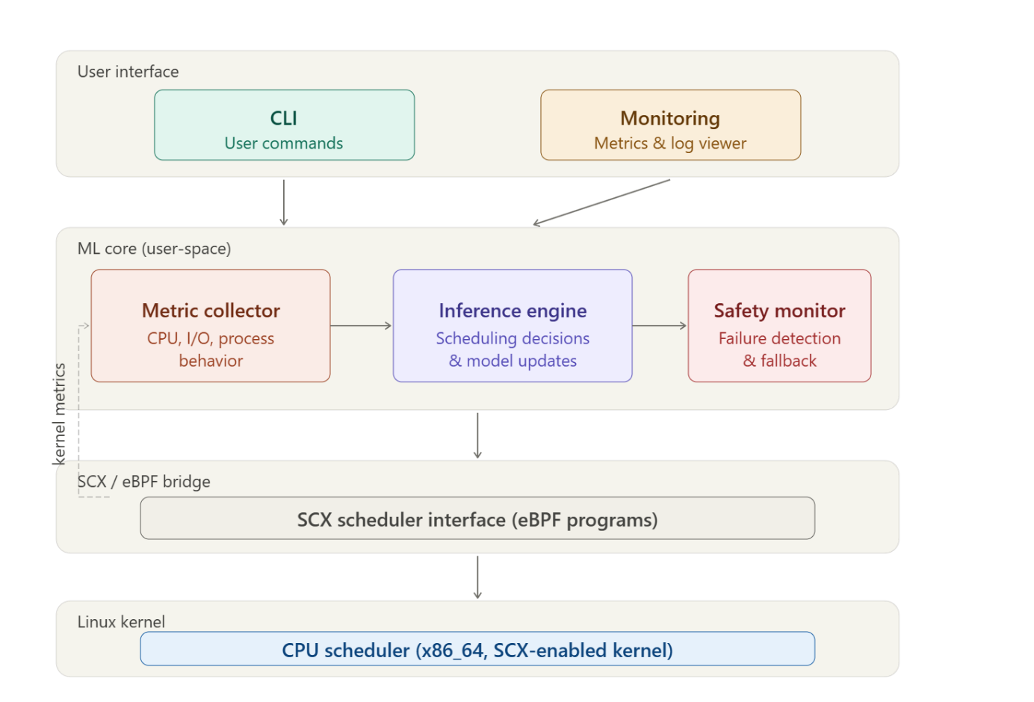
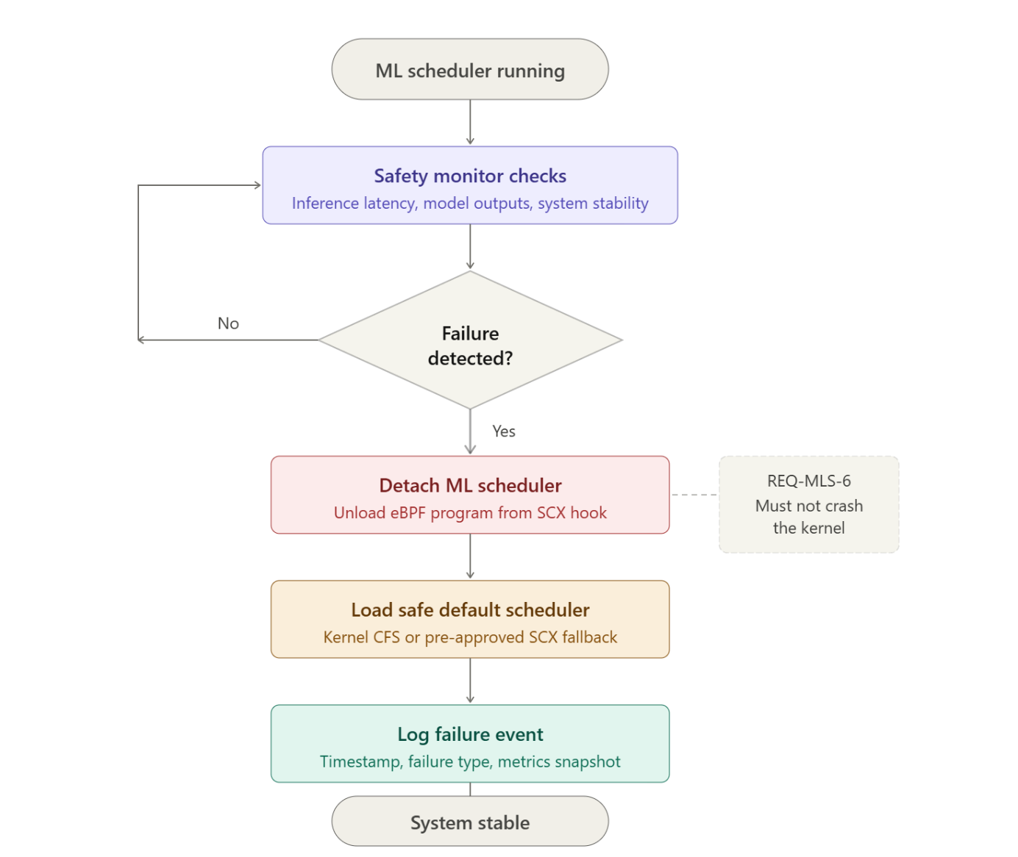

Ch6: Implementation & Test

6.1 Implementation

The implementation phase includes the development of SCX-compatible schedulers, CLI management tools, monitoring systems, and the Machine Learning integration module. The recovery system will continuously monitor scheduler health and automatically handle scheduler failures.

6.2 Test
In this section, describe and discuss your test procedures (unit tests, integration tests, system tests such as performance tests) and plans. Explain the types of testing employed at each step of the development.
You should give details about your testing plans, testing procedures and testing results. You should describe the testing purposes as well such as HCI testing, Performance testing etc. You may design some Alpha and Beta testing procedures.

Ch7: Evaluation
Give a general evaluation (performance, problems and so on) of your system.

Ch8: Impact of the Project & Compliance with the Constraints

8.1 Compliance with the Realistic Constraints
Your project may have some realistic constraints (cost, cost effectiveness, runtime and memory constraints, performance and so on). Some of these have already been mentioned in your SRS documents (I hope). Discuss here, whether these constraints are met or not. You may also discuss the new constraints you’ve encountered during the development and implementation (runtime problems, memory problems and so on). After the discussion, summarize your findings by filling out the appropriate boxes in the table below. Enter NA if an item does not apply to your project.
Table 8.1 Realistic Constraints & Conditions
Economic Factors | Please specify/explain realistic constraints and conditions (type, use, amount, etc.)
EXPENDITURES
Computer
Other Devices
Peripherals
Internet Connection
Software
Textbook/Magazine/Support Material
Human Resources
Other
FUNDING Sources
University Resources
Project support (SANTEZ, TÜBİTAK, and so on)
Support by the Industry
Self-funded
Other sources
OTHER CONSTRAINTS
Memory
Runtime efficiency
MANAGERIAL
Schedule (time)

8.2 Impact of the Project
Here, discuss the impact of your project on the society, health and environment. After a short discussion on these enter your views and points into the table below as appropriate. If an item is not applied to your project just say NA.
Table 8.2 Impact Assessment Report
Professional/Ethical Issues | Please specify/explain (existence of items, violation of items, awareness about items)
ETHICS/IT Law | Are there any applicable laws or legislation that will be relevant to the use and/or the construction of the system you are building? How have you addressed them?
Copyright in copying multimedia (sound, video, text)
Use of licensed software
Data Privacy
Use of patented products/ideas
IT Laws in Turkey (5661 and others)
IT Laws - International
Plagiarism
PROFESSIONAL |  | Liability/Sustainability Issues – What is the potential for liability either to yourself or your customer or users of the system, if it is misused or has flaws? Financial Impact – Have the financial costs of deploying and supporting the system been fully evaluated for yourself, the customer, users, and society as a whole?
Sustainability (use of Licensed and/or open source code)
Maintenance
Liability
Financial impact/Manufacturability
SOCIAL/POLITICAL/  ENVIRONMENTAL | Societal Issues – What is the potential for this system to be beneficial or detrimental to society as a whole? What have you done to address the potentially detrimental use? Are there any side-effects on the environment? Are there any potential political implications of the use of your system? What impact will this system have on the intended user community? Have you taken steps to safeguard the interests of that community?
Political impact
Impact on health
Gambling
Pornography
Equal Access/equity
Environmental impacts (energy, carbon footprint and so on)
Technology acceptance & Human/Business psychology
Security issues
PROFESSIONAL (CODES, STANDARDS, FRAMEWORKS) | What technical standards are relevant to the software system you have built? How have you ensured conformance? These could be government standards, industry standards, or even just conventions that are followed in the market for your system. Be sure to clearly identify what type of standard you are talking about and who is the relevant authority for the standard.
IEEE
ISO
ANSI
TSE
ITIL/COBIT
OTHER

Ch9: Conclusions
In this Chapter, give a short summary, findings, and results of your Project.
The contribution of your project to the society to help to manage the problem that you have discussed at the beginning of the project and aimed to address.

Appendix A
Program listings, and other attachments as Appendix A, Appendix B, and so on.

References
Yazici, A. Altaş,İ., & Demiray, U. (2001). “Distance Education on the net: a model for developing countries”, TOJDE, Vol.2, No.2. (example for journal article reference)
Wall, J.E. (2000). “Technology-delivered assessment: diamonds or rocks?”, Retrieved January 29, 2014, from http://www.universitas.edu.au/ (example for URL reference)
Sweller,J., van Merrienboer, J.J.G., & Pass, F.G.W.C. (1998). “Cognitive architecture and instructional design”, Educational Psychology Review, Vol.10, No.3, pp.251-296. (example for review article reference)
Phillips, J.J. (1997). Handbook of training evaluation and measurement methods (3rd. Ed.) London: Gulf Publishing. (example for book reference)
***Use double-space and sort according to take last name of the first author.

